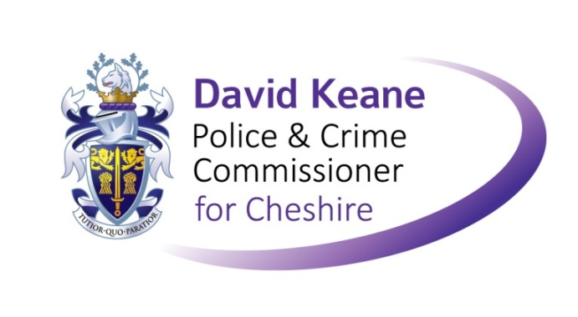

**OPCC VICTIM SERVICE PROVIDER WORKSHOP Evaluation Form**

Date:July 2016Facilitator: MICHAEL LLOYD (MLR)

*For questions 1 to 4, please highlight one response.*

**Strongly Strongly**

**agree disagree**

1. The event was useful to me 1 2 3 4 5
2. The event was well paced within the allotted time 1 2 3 4 5
3. The event was enjoyable 1 2 3 4 5
4. The event helped me to make new contacts 1 2 3 4 5

# Please rate the following:

Excellent Very Good Good Fair Poor

1. Speakers & presentations ❑ ❑ ❑ ❑ ❑
2. Group exercise ❑ ❑ ❑ ❑ ❑
3. Meeting space & refreshments ❑ ❑ ❑ ❑ ❑
4. The event overall ❑ ❑ ❑ ❑ ❑
5. What did you most appreciate/enjoy/think was best about the event? Any suggestions for improvement?

**Thank you!**

# Please return this form to [rainbow.langdale-smith@cheshire.pnn.police.uk](mailto:rainbow.langdale-smith@cheshire.pnn.police.uk)

## 